EAST FREEDOM LODGE #328
Prince Hall Affiliation
15th District North Carolina Jurisdiction PO Box 882 Raeford, NC 28376
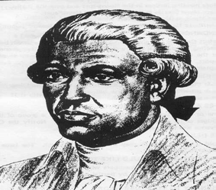

13 February 2024

Dear Guidance Counselors,

I am writing to inform you about scholarship opportunities available through the East Freedom Masonic Lodge #328 in Raeford, NC. We are pleased to announce the PM Willie Guyton Scholarship and the PM Frank Harris Scholarship, each valued at $1000. These scholarships aim to support students in their pursuit of higher education and are awarded to the applicants who best meet the criteria outlined in the enclosed guidelines.

To be eligible for consideration applicants must submit their completed applications along with references and transcripts by May 18, 2024. We kindly request that you share this information with students who meet the criteria and may benefit from these scholarship opportunities.

East Freedom Masonic Lodge #328 is proud to serve the Raeford and Hoke County communities by supporting the educational aspirations of our youth. We believe in the importance of continuing education and are committed to assisting deserving students in their academic endeavors.

If you have any questions or require further assistance, please do not hesitate to contact me at (276) 806-6877 or mark.d.alston@gmail.com. Thank you for your attention to this matter, and we appreciate your assistance in spreading the word about these scholarship opportunities.

Sincerely,

Mark D. Alston
Mr. Mark D. Alston
Junior Deacon
Scholarship Committee Chair
East Freedom Masonic Lodge #328

